**The Science of Safety: Why Air Travel is Incredibly Secure**

Air travel remains one of the safest modes of transportation, thanks to a meticulous framework designed to ensure your safety from takeoff to touchdown. For those considering air travel, we've outlined key reasons why you can fly with confidence.

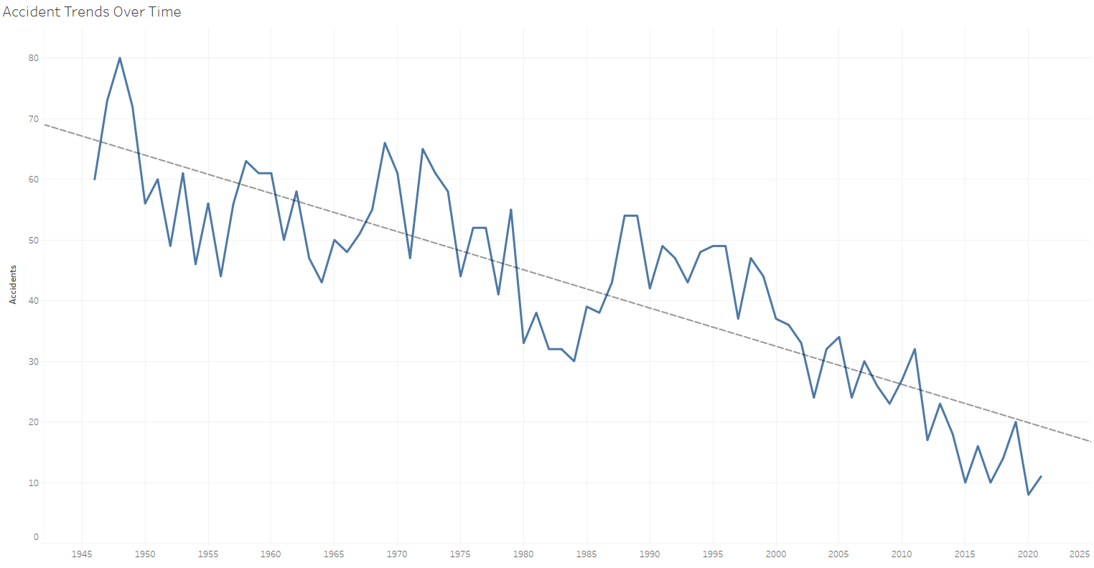

**Checks and Balances:**

Every flight involves an intricate web of checks and balances. Collaboration among various divisions, including flight crews, air traffic control, and ground personnel, is essential for a smooth and secure journey. These coordinated efforts help identify and mitigate potential risks, ensuring your safety is the top priority.

**Training:**

Pilots undergo rigorous training, including accumulating a minimum of 1,500 flying hours, even after obtaining their licenses. This demanding process equips them to handle diverse in-flight scenarios, emergencies, and unexpected challenges with poise and proficiency.

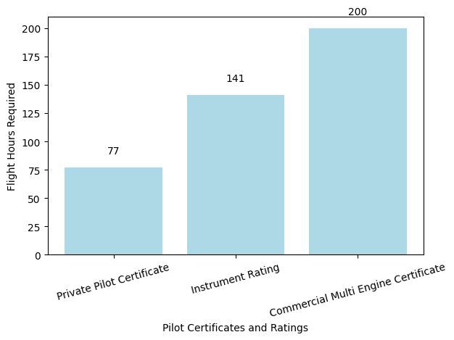

**Regulations:**

The Federal Aviation Administration (FAA) maintains strict oversight and regulation of pilots, air traffic controllers, and aircraft dispatchers. These stringent regulations are in place to uphold high safety standards across the aviation industry, ensuring that everyone involved is held to the highest standards of competence and safety.



**Conclusion:**

Air travel is backed by a robust system of checks, training, technology, and regulations that collectively ensure your safety. The visualizations included offer a clear perspective on accident trends, pilot training, and technological advancements, reinforcing the idea that flying is not just convenient but incredibly secure. When you step onto an aircraft, you can do so with confidence, knowing that your journey will be as safe as it is efficient.